BUILDTRACK
Construction Project Management & Site Monitoring Platform

MILESTONE 1 DOCUMENTATION
Modules 1–3: Authentication, Administration & Project Manager

Document Item | Details
Project | BuildTrack – Construction Project Management & Site Monitoring Platform
Milestone | Milestone 1
Modules Covered | Module 1 – Authentication; Module 2 – Administration; Module 3 – Project Manager
Technology | Angular frontend; Python FastAPI backend; SQLAlchemy/database layer; JWT-based authentication
Document Type | Technical Project / Internship Documentation
Evidence Basis | Current BuildTrack project source code and reference milestone specification

Version: 1.0

1. Milestone Overview
Milestone 1 establishes the core access, administration and project-management foundation of BuildTrack. The implemented frontend contains dedicated authentication pages, an administrator workspace with user and project management screens, and a Project Manager workspace containing project monitoring and planning views. The backend contains FastAPI endpoints and database models supporting user authentication and project-related operations.
Module | Purpose | Main Implemented Areas
Module 1 – Authentication | Control user entry into BuildTrack and establish authenticated sessions. | Login, Remember Me, JWT token storage, role-based redirection, registration route, password-reset route.
Module 2 – Administration | Provide administrators with centralized control over users, projects and administrative monitoring. | Admin dashboard, user directory/detail/add/edit/view screens, project listing/add/edit/view/detail screens, analytics, reports and audit-log routes.
Module 3 – Project Manager | Give project managers a consolidated view of projects, milestones, site progress, resources, workforce, procurement and budget information. | Dashboard, My Projects, Project Details, Project Schedule, Milestones, Site Engineers, Contractors, Site Progress, Resource Allocation, Workforce, Procurement Requests, Budget Tracking, Reports, Notifications and Profile.

2. Milestone Objectives
- Establish the authentication entry point and authenticated role-based navigation.
- Provide administrator-facing screens for user and project administration.
- Provide a Project Manager workspace for project-level monitoring and planning.
- Connect the frontend structure with backend authentication and project APIs where implemented.
- Create a clear navigation foundation for the later construction-management modules.

3. System Architecture Used in Milestone 1
The project uses Angular for the frontend and Python FastAPI for the backend. The frontend uses Angular standalone components and route-based navigation. The backend uses FastAPI, SQLAlchemy and a database session layer. JWT tokens are generated during login and are used by the application to identify the authenticated user. The frontend stores the access token and selected user information in localStorage and redirects the user according to the returned role.
Layer | Observed Implementation
Frontend | Angular 22 project structure with standalone components, Angular Material components and route configuration.
Routing | Angular Routes with dedicated authentication, administrator, Project Manager and other module paths.
Backend | Python FastAPI application with routers for project, milestone, worker, contractor, site-engineer, schedule and project-closure operations.
Authentication | JWT access token creation and verification; password hashing/verification using Passlib bcrypt.
Database Access | SQLAlchemy engine/session configuration and ORM models.
Authorization | Angular authGuard/roleGuard are defined and used on protected module routes such as Site Engineer; login response also supplies the user's role for redirection.

4. Module 1 – Authentication

4.1 Objective
The Authentication module provides the entry point into BuildTrack and supports credential-based login, session persistence preferences and role-specific navigation. The current frontend exposes Login, Register and Reset Password routes.

4.2 Features
Feature | How it works in BuildTrack | Role / Output
Login | The user enters email and password and selects Login. The Angular component sends email, password and remember_me to AuthService. A successful response stores the access token, role, full name and expiry time. | All authenticated users / authenticated session and role-specific navigation.
Remember Me | The login request includes the remember_me value. The backend creates a longer-lived token when this option is enabled. | User / extended token lifetime when enabled.
Password Visibility | The login page provides a visibility control that toggles the password field between hidden and visible states. | User / easier credential entry.
Role-based Redirect | After successful authentication, the frontend checks the returned role and redirects Administrator to the Admin Dashboard, Project Manager to the Project Manager Dashboard, and Site Engineer to the Site Engineer Dashboard. | System / role-specific workspace.
Registration | A /register route and Register component are present. The current frontend component is a placeholder screen, while the backend exposes a /register endpoint that validates email and employee-ID uniqueness, confirms passwords and creates a user. | New user / registration workflow is partially implemented.
Password Reset | A /reset-password route and component are present. The current frontend component is a placeholder. The backend exposes a /forgot-password endpoint for initiating password recovery. | User / recovery workflow is partially implemented.

4.3 Authentication Workflow
Step | User Action | System Response | Result
1 | Open BuildTrack. | Default route redirects to /login. | Login screen is displayed.
2 | Enter email and password. | Angular binds the values to the login component. | Credentials are prepared.
3 | Optionally select Remember Me. | remember_me is included in the request. | Token lifetime preference is passed to backend.
4 | Click Login. | AuthService sends the login request to the backend. | Authentication is attempted.
5 | Credentials are valid. | Backend verifies the user and returns JWT, role, name and expiry information. | Authenticated response is received.
6 | Frontend stores authentication data. | access_token, role, full_name and expires_at are stored in localStorage. | Client-side session information is available.
7 | System checks role. | Router navigation is selected according to role. | User enters the appropriate workspace.

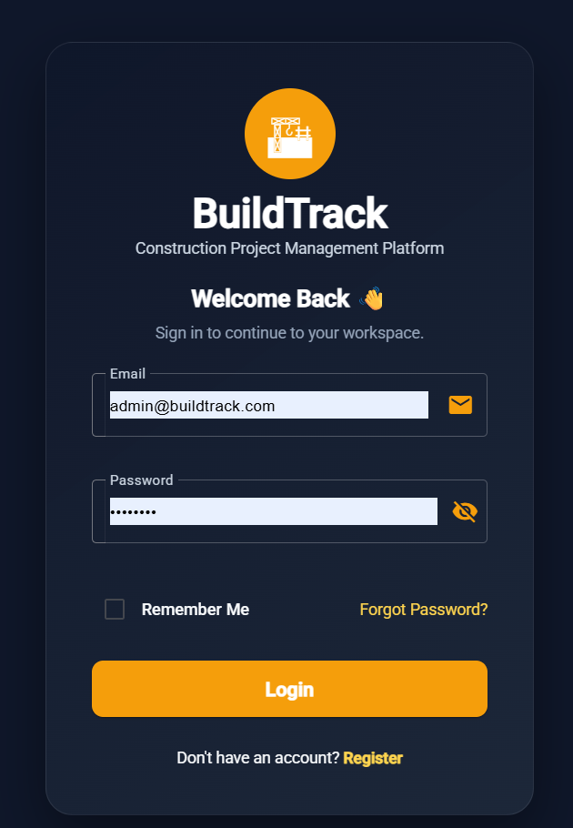
Figure 1: BuildTrack Login Page
Authentication Login Screen
Screenshot placement: capture the actual /login page showing the BuildTrack branding, email and password fields, Remember Me option, Login button and Register link.

4.4 Technical Implementation
- Angular Login component is implemented as a standalone component.
- Angular FormsModule and Material form/input/button/icon/checkbox modules are used in the login page.
- AuthService is called through login(loginData).
- Successful authentication stores access_token, role, full_name and expires_at in localStorage.
- FastAPI provides /login and /register endpoints and uses JWT creation/verification.
- Passwords are hashed and verified using a Passlib bcrypt context.
- The backend checks whether the account is verified before allowing login.

4.5 Module Outcome
The authentication foundation is present and the login workflow is connected to the backend authentication service. The Register and Reset Password frontend screens are currently placeholders and should be completed before describing those two UI workflows as fully operational.
5. Module 2 – Administration

5.1 Objective
The Administration module provides an administrator workspace for monitoring the overall system and managing users and projects. The route configuration includes an AdminLayout with dedicated dashboard, user-management and project-management screens, together with analytics, audit-log and report routes.

5.2 Administrator Dashboard
The Admin Dashboard presents high-level operational indicators and supporting project information. The implemented page contains KPI cards for Active Projects, Workforce, Budget and Procurement, followed by project progress, a focus card and a live project table.
Dashboard Area | Displayed Information
Active Projects | 24, with a weekly change indicator.
Workforce | 356, with an attendance indicator.
Budget | ₹2.4 Cr, with utilization indicator.
Procurement | 8 pending approvals.
Project Progress | Visual project-progress component.
Focus / Live Projects | Supporting focus information and a live project table.

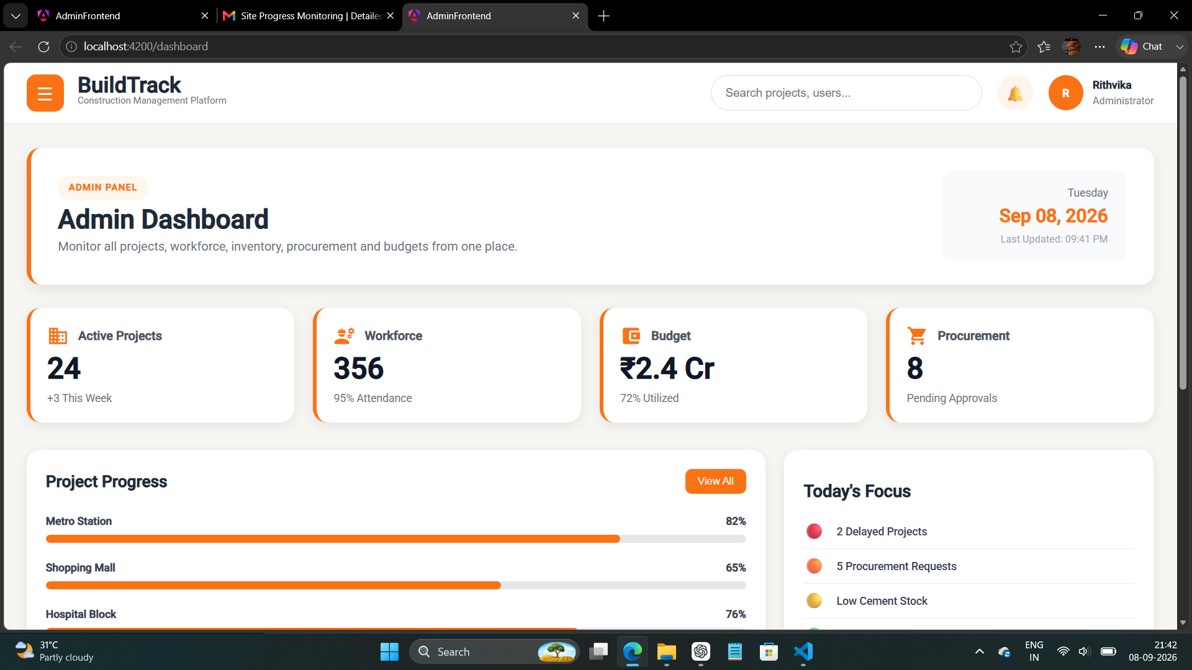
Figure 2: BuildTrack Administrator Dashboard
Administrator Dashboard

5.3 User Management
The user-management area contains a User Directory with search capability and administrative actions. Separate screens are available for adding, viewing and editing users. The Add User form contains personal information, employment details and account details.
Screen | Observed Functionality
User Directory / User Details | Search users by name, employee ID or role; display user records with ID, Employee, Role, Department, Status and Actions.
Add User | First Name, Last Name, Email Address, Phone Number, Gender, Role, Department, Employee ID, Status, Password and Confirm Password fields.
View User | Displays personal and employment information including name, email, phone, gender, employee ID, department, role, status and joining date.
Edit User | Provides editable user information and account/status fields with navigation back to user details.

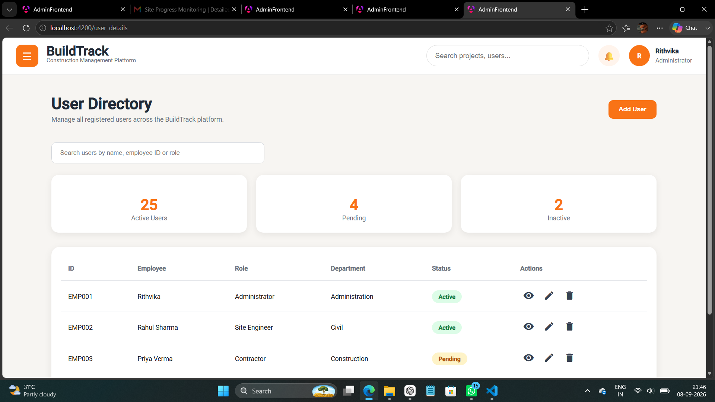
Figure 3: BuildTrack Administrator – User Directory
User Directory
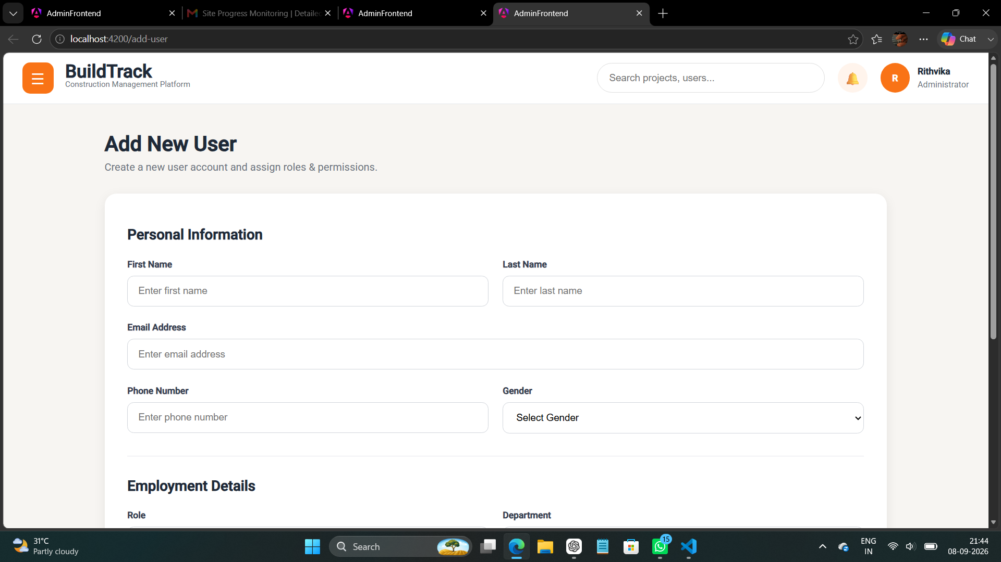
Figure 4: BuildTrack Administrator – Add New User
Add User Form
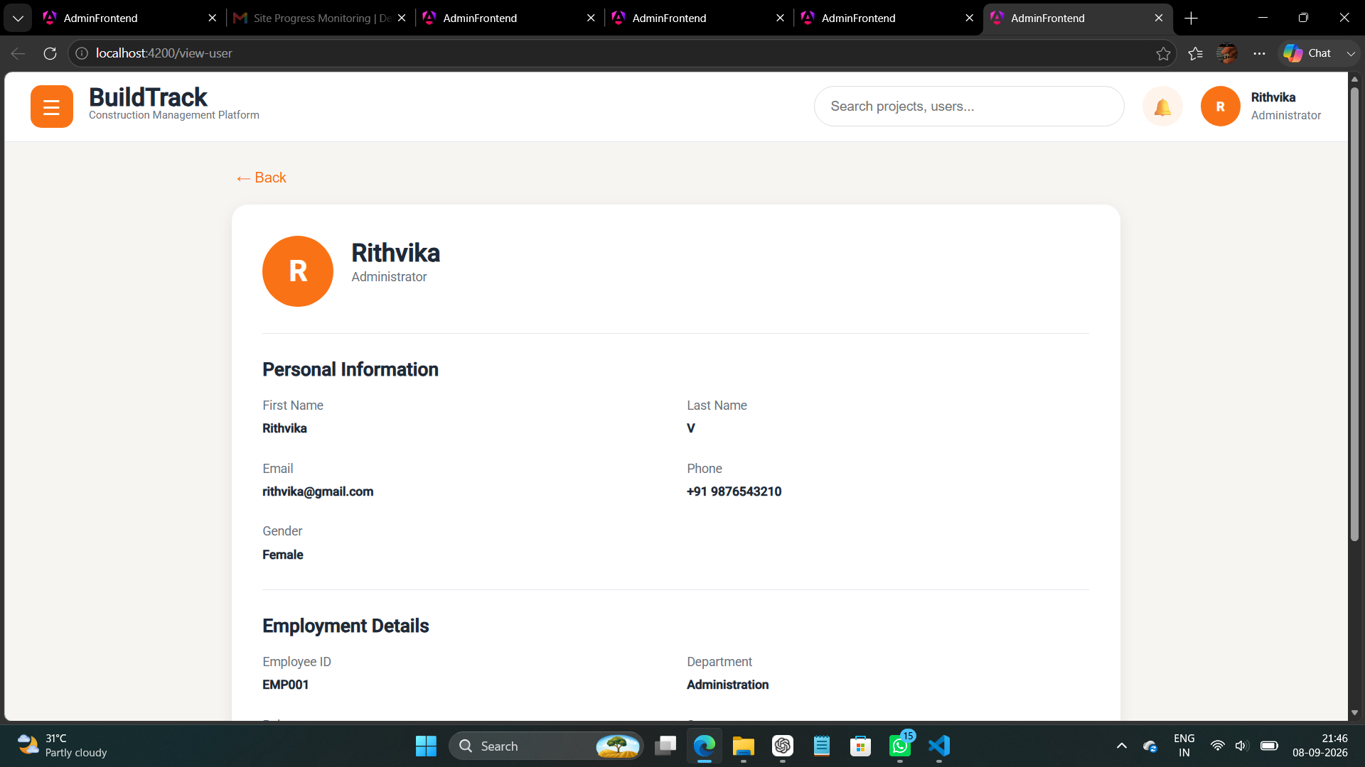
Figure 5: BuildTrack Administrator – View User
View User

Figure 6: BuildTrack Administrator – edit User
edit User
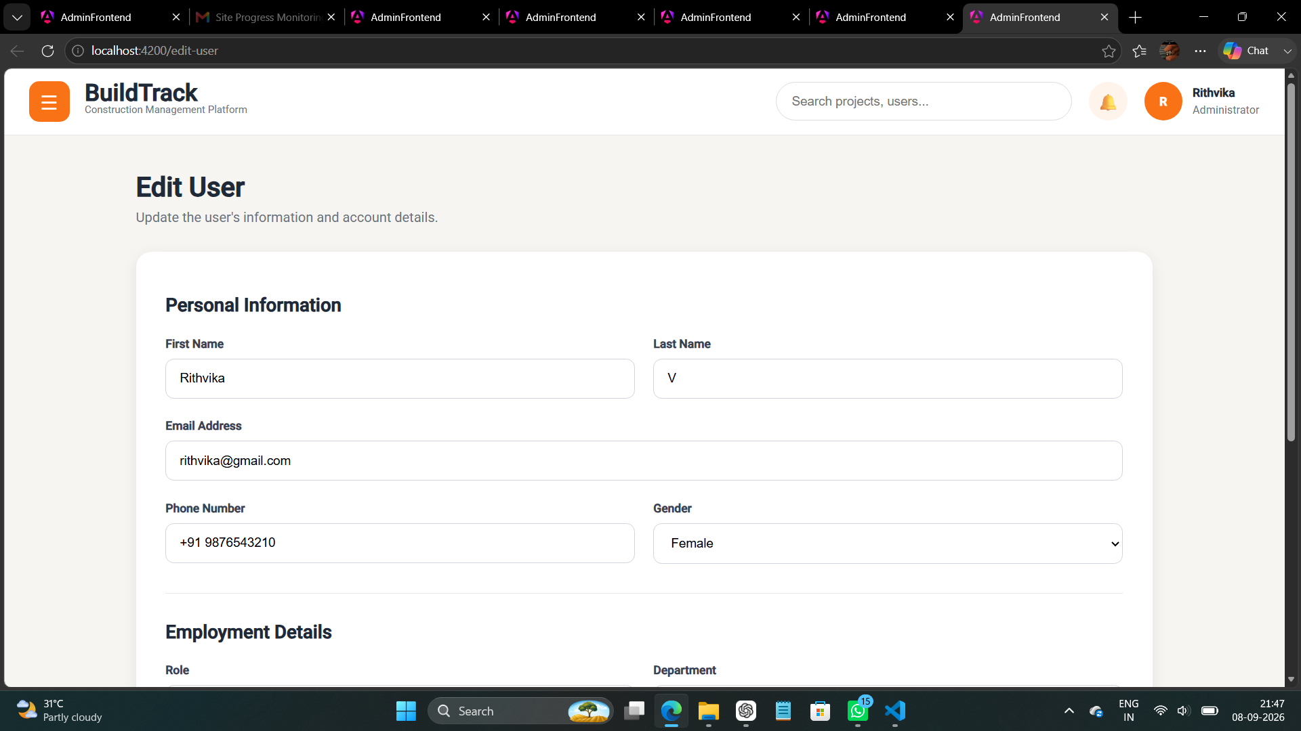

5.4 Project Management
The administrator project-management area provides project listing and project information screens. The Add and Edit Project forms cover project identity, client and location information, management assignments, status, budget, dates and description. The View Project screen displays financial, timeline, progress and team-related information.

Screen | Observed Functionality
Project Management / Projects | Project listing/summary area with project-management navigation.
Add New Project | Project Name, Project ID, Client Name, Location, Project Manager, Site Engineer, Status, Budget, Start Date, Expected End Date and Description.
Project Details | Dedicated project-detail view.

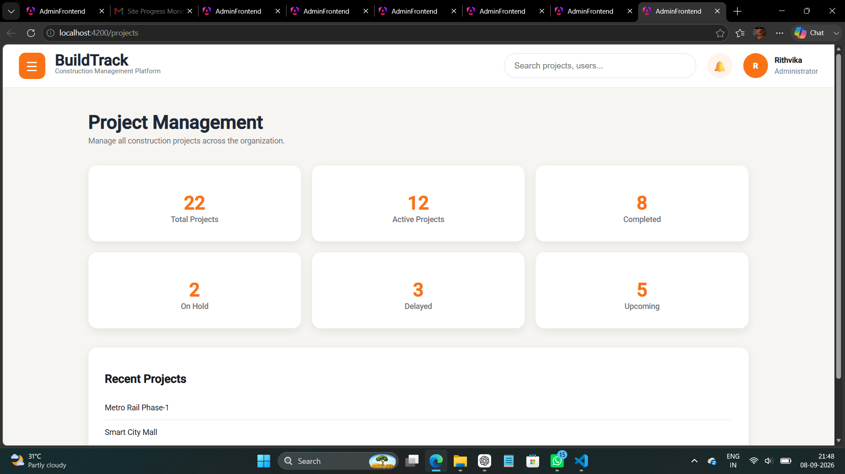
Figure 6: BuildTrack Administrator – Project Management
Project Management
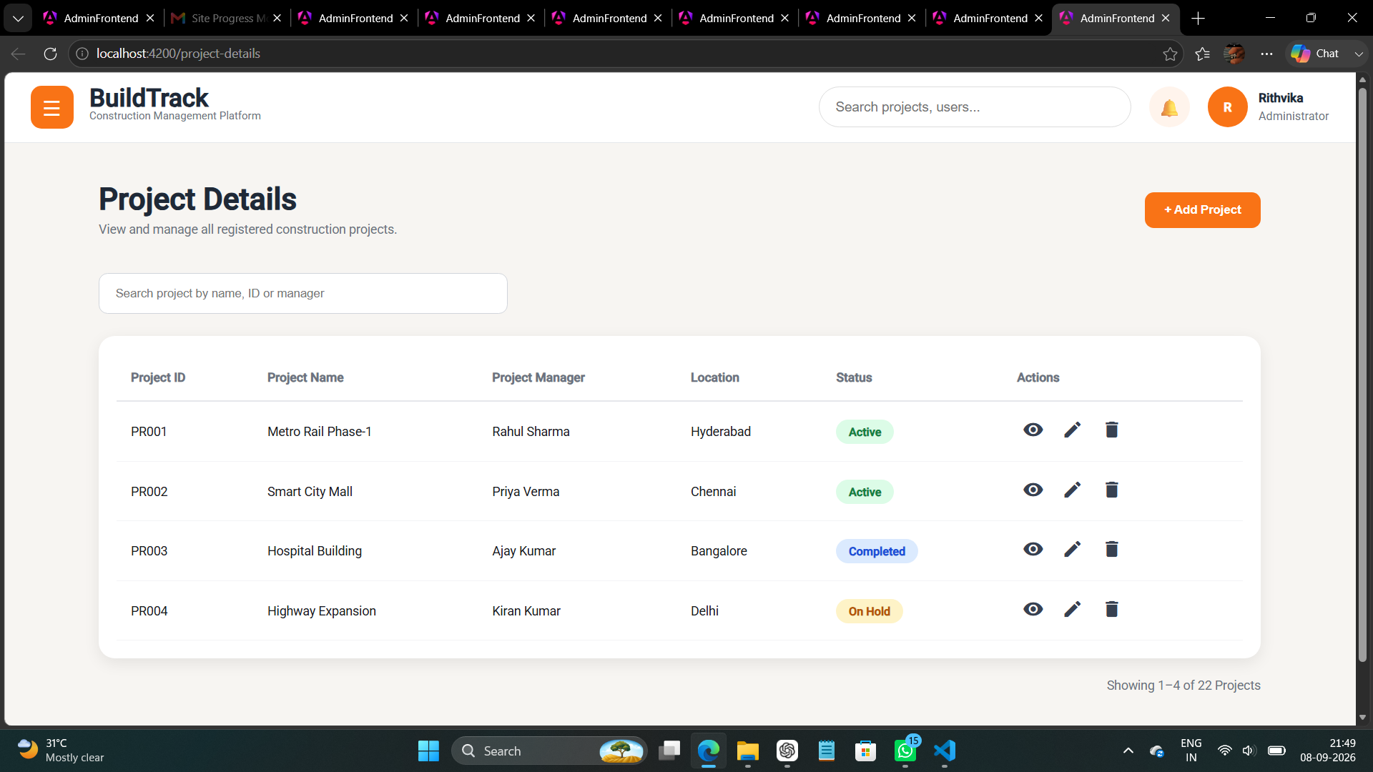
Figure 7: BuildTrack Administrator – Project details
Project details

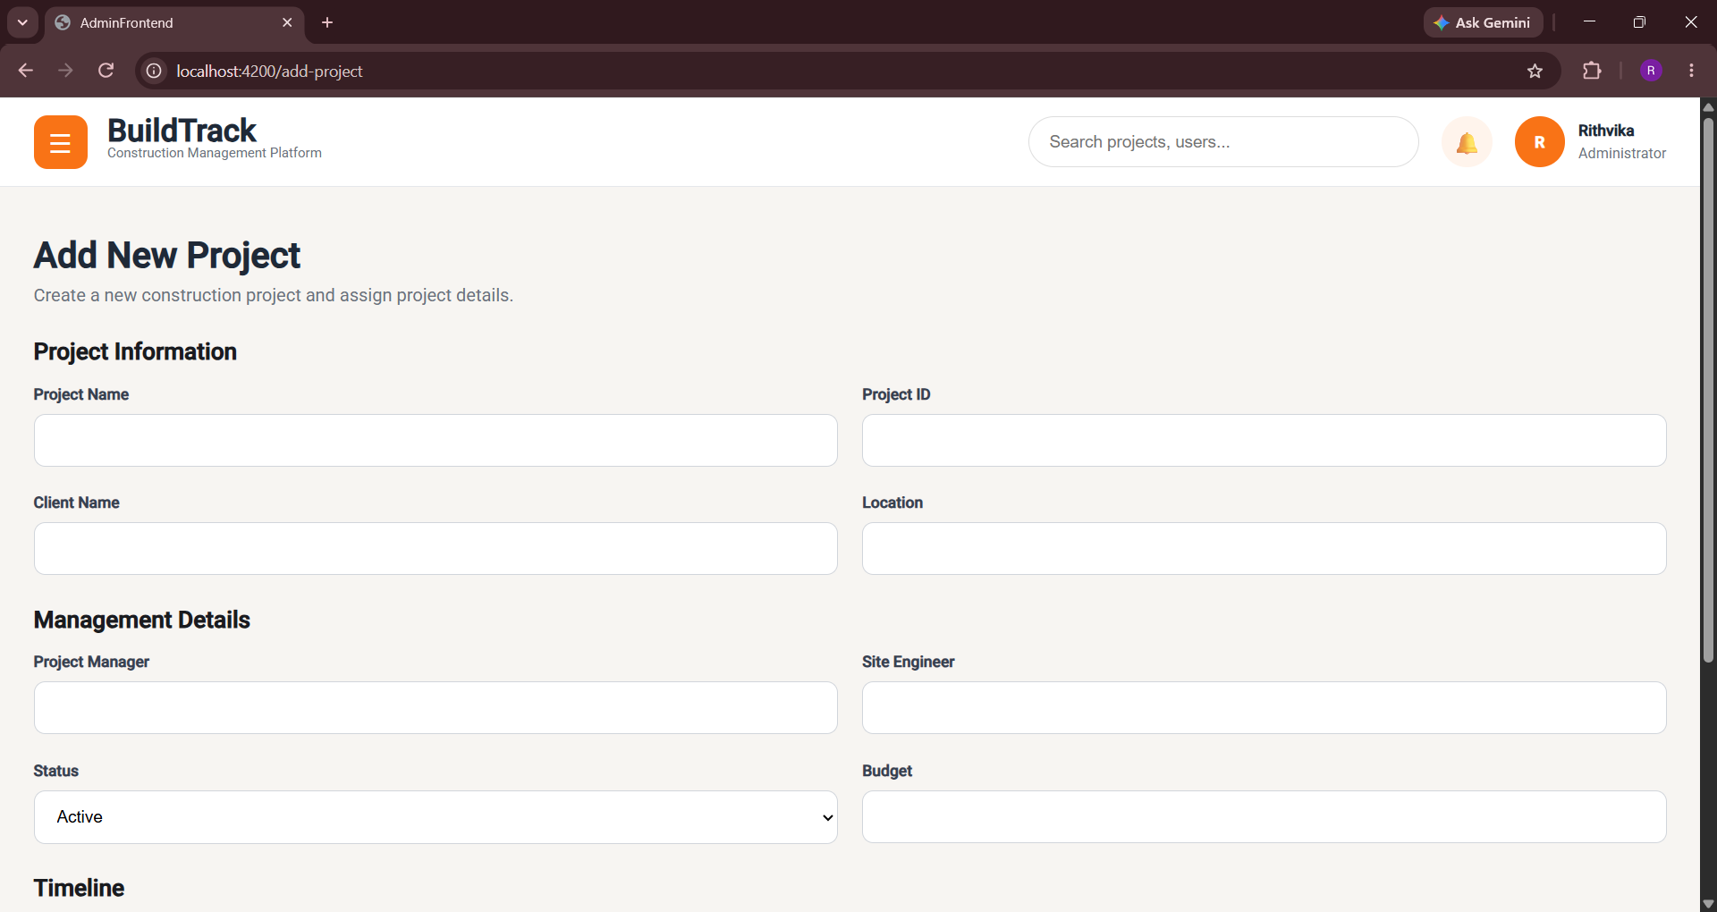
Figure 8: BuildTrack Administrator – Add New Project
Add New Project

5.5 Administrative Navigation
The Admin route configuration includes dashboard, add/view/edit user, project listing/details/add/edit/view, analytics, audit logs and reports. These routes establish the navigation foundation for administrative monitoring and later integration of broader system functions.

5.6 Administrator Workflow
User Action | System Response | Result
Open Admin Dashboard | AdminLayout loads the dashboard component. | Administrative overview is displayed.
Open User Directory | User-management screen displays user records and actions. | Administrator can inspect the user directory.
Select Add User | Add User form opens. | Administrator can enter user and role information.
Select View/Edit User | Corresponding user screen opens. | Administrator can inspect or modify user information.
Open Project Management | Project listing/detail navigation is displayed. | Administrator can inspect projects.
Select Add Project | Project form or detail screen opens. | Project information can be entered, reviewed or edited.

5.7 Module Outcome
The administrative foundation is implemented at the frontend level with dashboard, user-management and project-management screens. The screens provide the required navigation and data-entry structures. The exact level of backend persistence should be demonstrated from the running application before claiming every UI action as fully integrated.

6. Module 3 – Project Manager

6.1 Objective

The Project Manager module provides a centralized workspace for monitoring assigned projects and related construction activities. The implemented dashboard brings project progress, milestones, site progress, resources, workforce, procurement, budget, delays, analytics, reports, notifications and profile information into one workspace.

6.2 Project Manager Dashboard

The Project Manager Dashboard displays four top-level dashboard cards: Assigned Projects, Completed Milestones, Delayed Activities and Budget Utilization. The page then presents sections for Assigned Projects, Project Milestones, Site Progress, Resource Allocation, Workforce Summary, Procurement Requests, Budget Tracking, Delayed Activities, Project Analytics, Reports, Recent Updates, Notifications and Profile.

Dashboard Section | Observed Information
Summary Cards | Assigned Projects, Completed Milestones, Delayed Activities and Budget Utilization.
Assigned Projects | Project, client, status and completion percentage.
Project Milestones | Milestone/task, completion percentage, deadline and status.
Site Progress | Site, engineer, progress and status.
Resource Allocation | Resource, assigned project and availability/allocation status.
Workforce Summary | Team, worker count and supervisor.
Procurement Requests | Material, supplier and request status.
Budget Tracking | Project, budget, spent and remaining amount.
Delayed Activities | Activity, reason and delay duration.
Project Analytics | Project completion, resource utilization, budget utilization and on-time delivery.
Reports / Notifications / Profile | Navigation/content areas for reporting, updates and Project Manager profile.

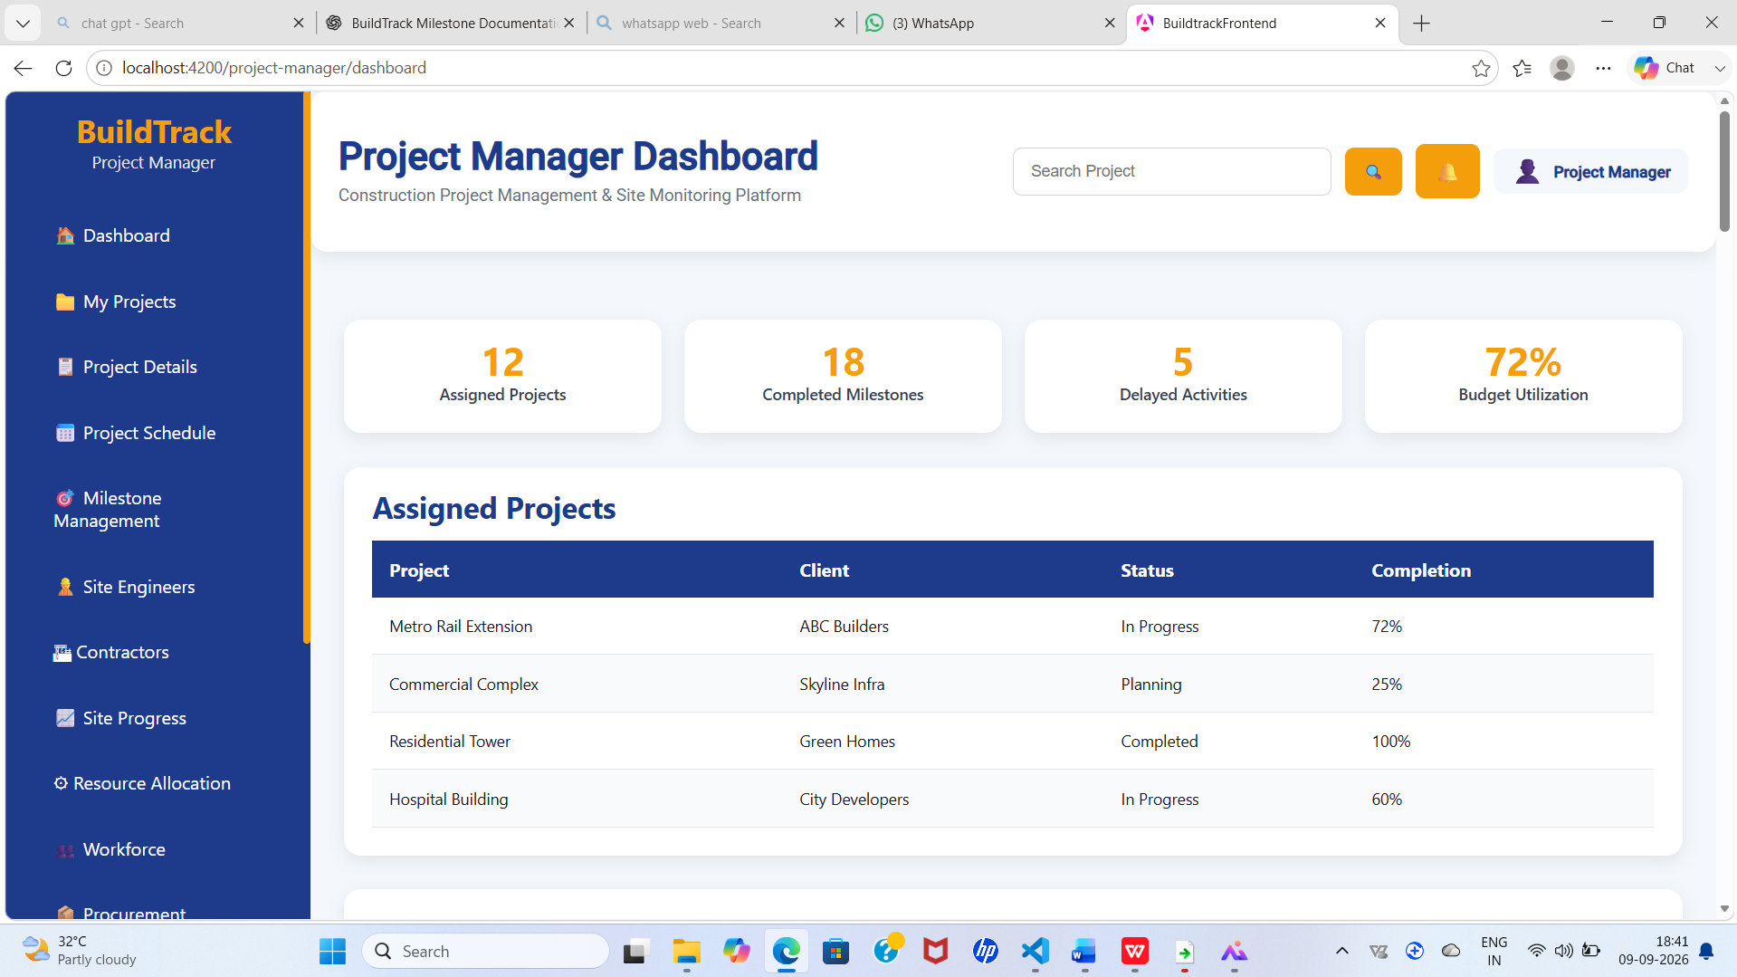

Figure 9: BuildTrack Project Manager Dashboard
Project Manager Dashboard

6.3 My Projects
The My Projects screen provides project-level filtering and summary indicators. It includes a search field for project or client and a project table containing Project Name, Code, Client, Location, Status, Priority, Budget, Completion, Start Date, End Date and Actions.
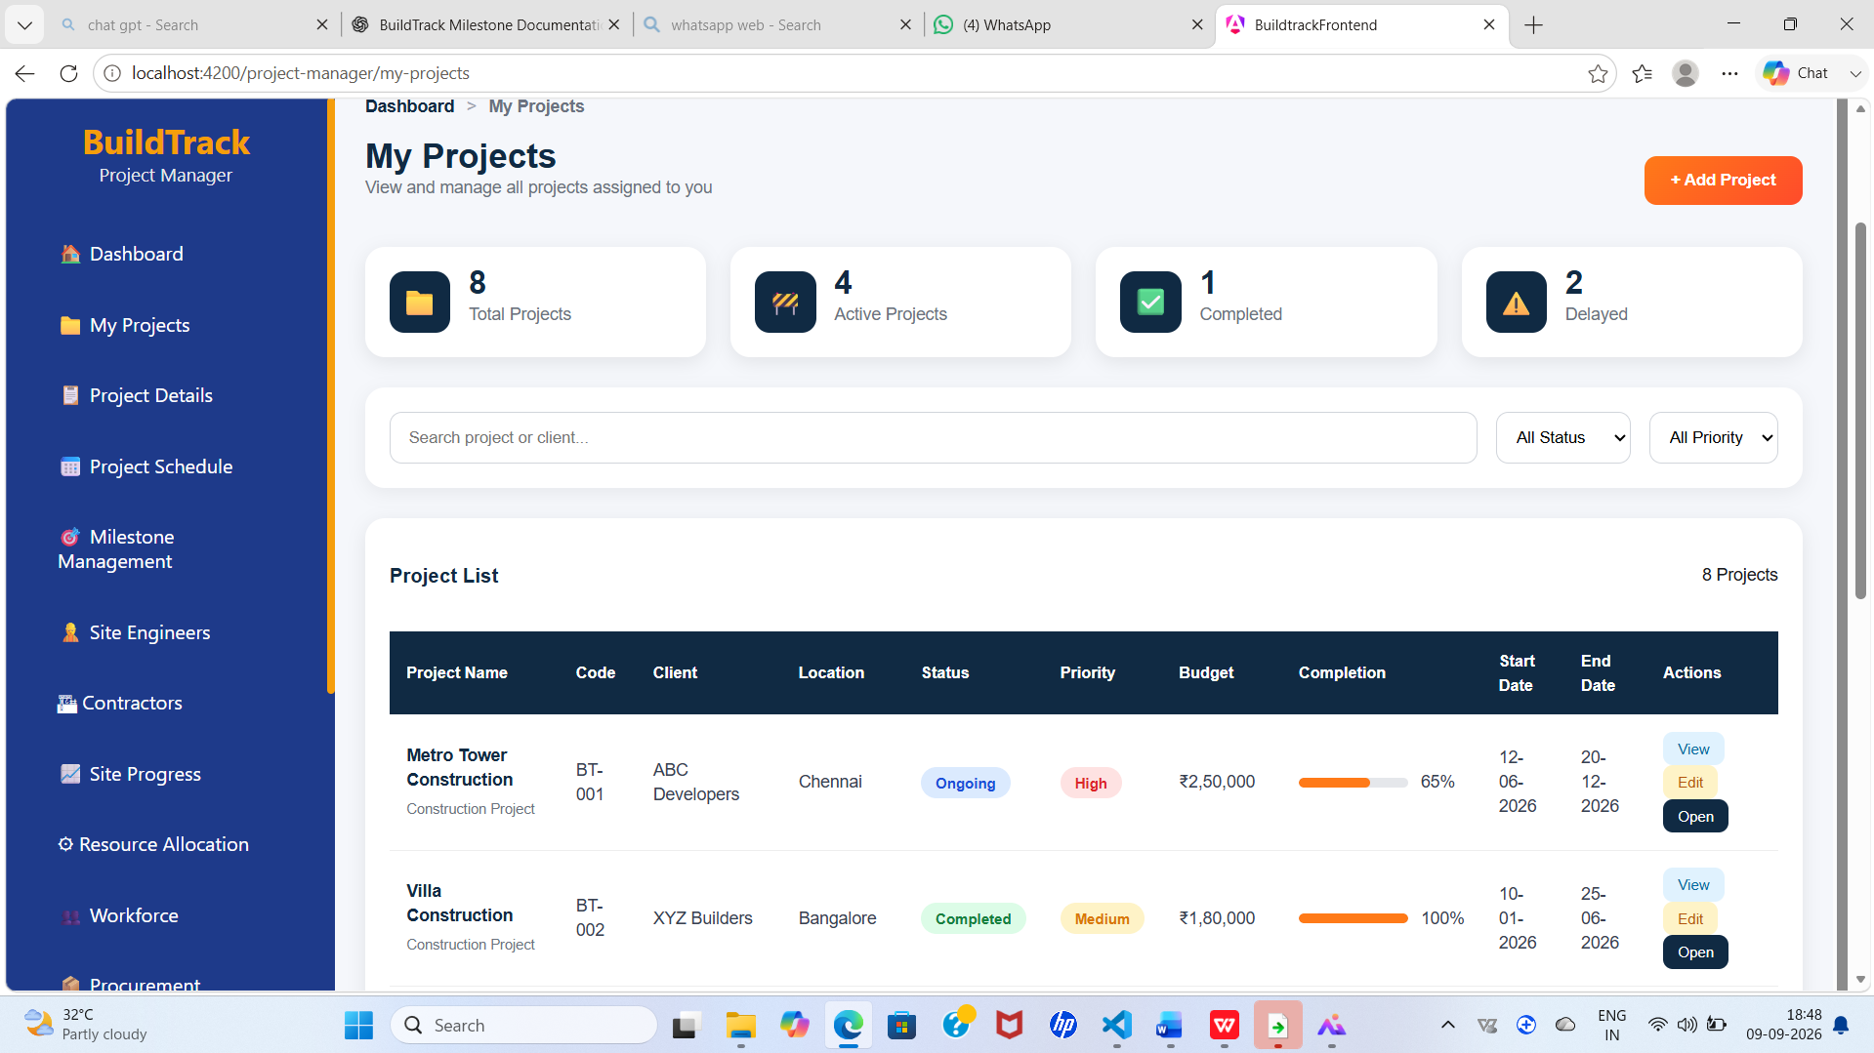

Figure 10: BuildTrack Project Manager – My Projects
My Projects

6.4 Project Details
The Project Details screen provides basic project information including project code, client, location, budget, start/end dates, status and priority. It also includes project progress, milestone details, site engineers, contractors, resources and materials.

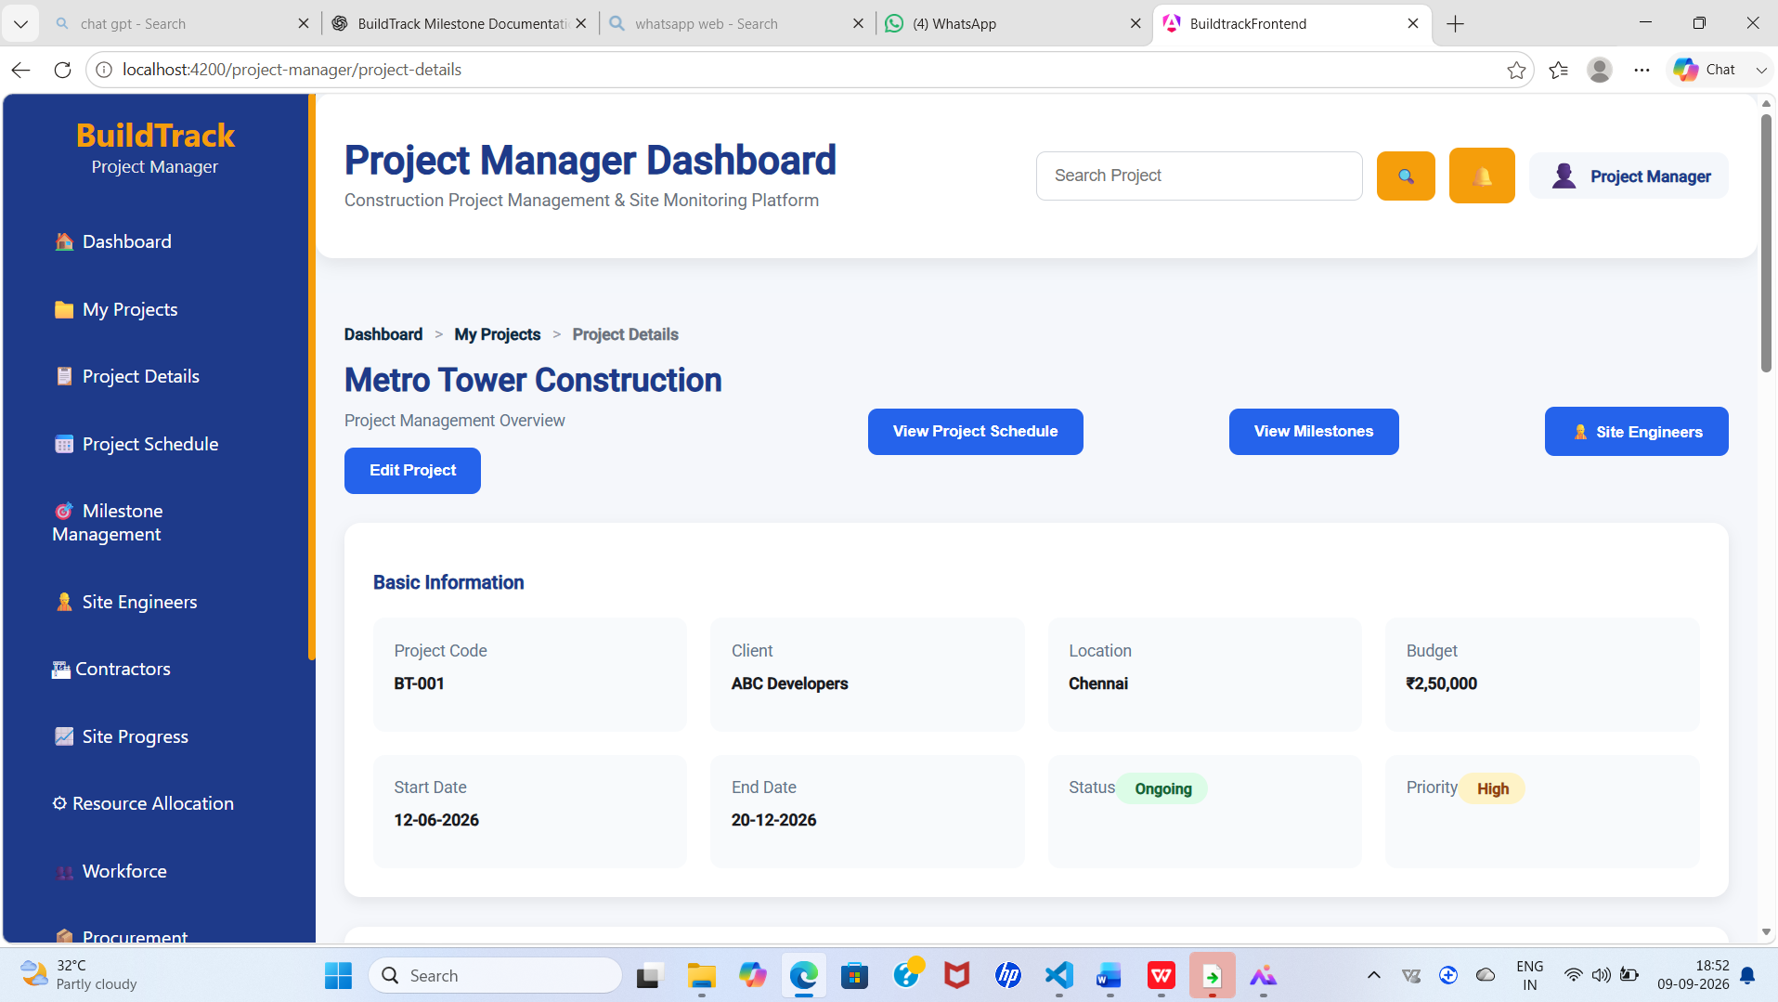

Figure 11: BuildTrack Project Manager – Project Details
Project Details

6.5 Project Schedule
The Project Schedule page provides a project timeline and an activity schedule. The timeline represents stages such as Foundation, Structure, Electrical, Plumbing, Painting, Finishing, Inspection and Handover. The activity table contains task name, start date, end date, duration, assigned engineer, status and actions.

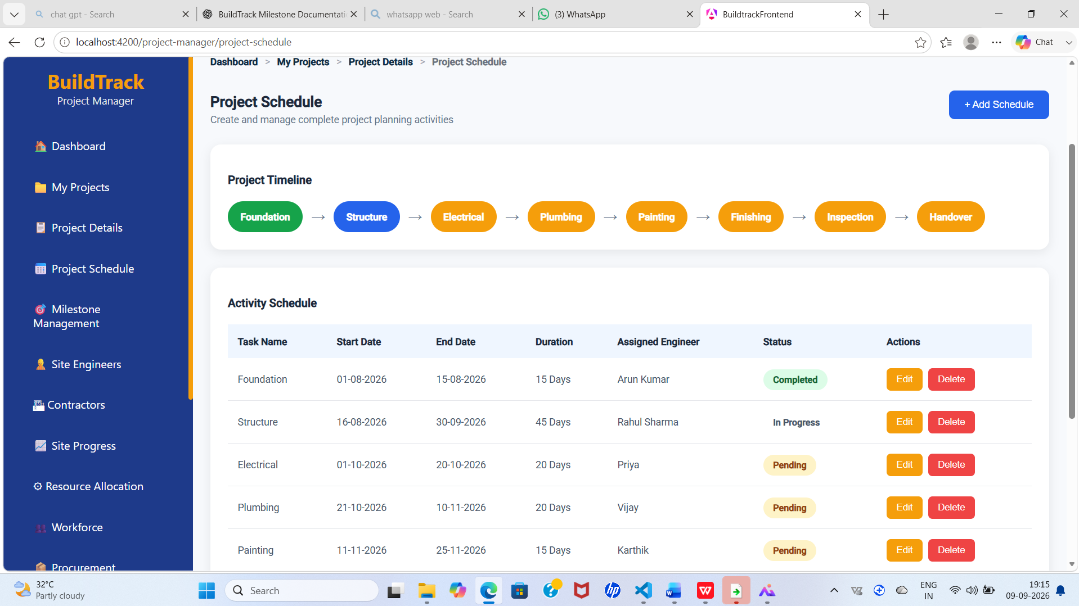

Figure 12: BuildTrack Project Manager – Project Schedule
Project Schedule

6.6 Milestone Management
The Milestones page provides a milestone timeline and a milestone-details table. The displayed milestone workflow includes stages such as Foundation Complete, Structure Complete, Electrical Complete, Plumbing Complete, Interior Complete, Final Inspection and Handover. The table records planned date, actual date, status, delay and remarks, with an action to complete a milestone.

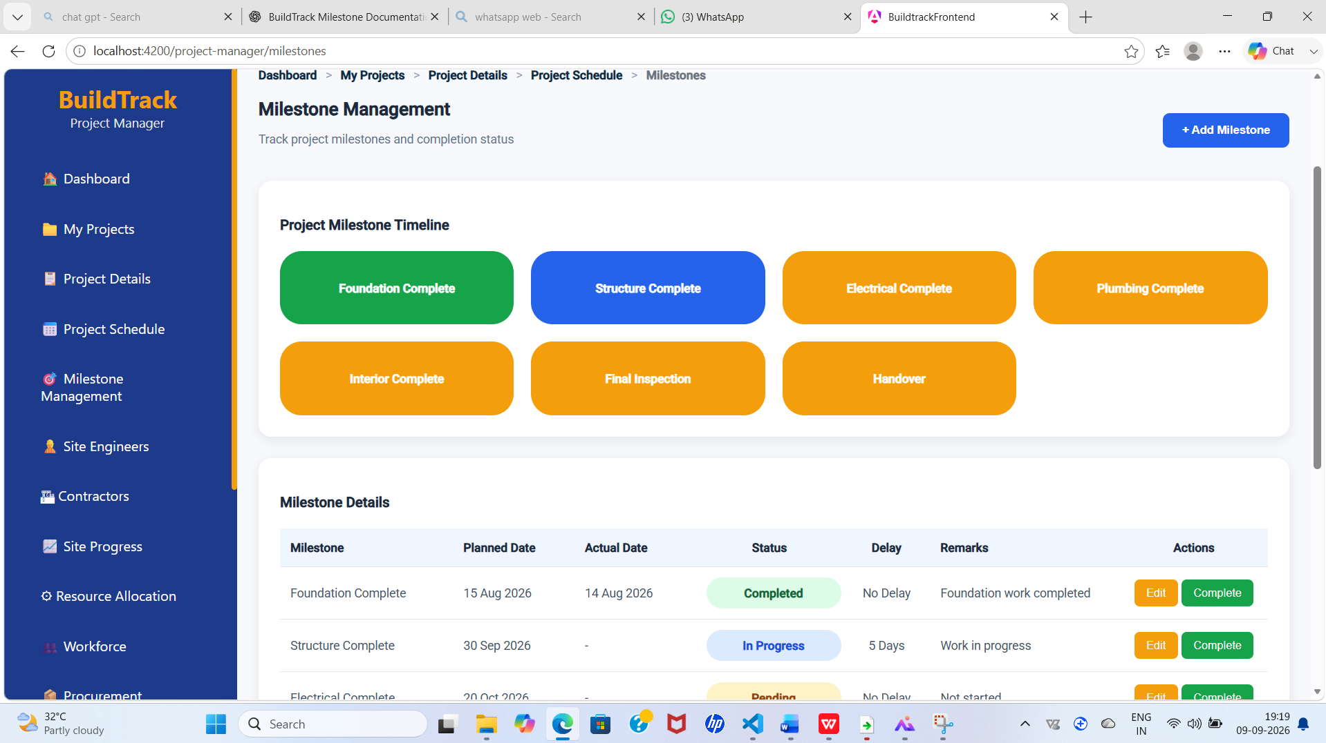

Figure 13: BuildTrack Project Manager – Milestone Management
Milestone Management

6.7 Supporting Project Manager Pages

Page | Purpose
Site Engineers | View project-associated site engineers and assignment information.
Contractors | View contractor/company and specialization information.
Site Progress | Monitor site-level progress and status.
Resource Allocation | View allocated resources against projects.
Workforce | View workforce/team information.
Procurement Requests | View material/supplier procurement request information.
Budget Tracking | View project budget, spending and remaining amount.
Reports | Access Project Manager reporting area.
Notifications | View Project Manager notifications/updates.
Profile | Display Project Manager profile information.

6.8 Site Engineers

The Site Engineers page allows the Project Manager to view site engineers associated with the project.
It provides information about assigned engineers and their project responsibilities.
This helps the Project Manager monitor and coordinate site-level activities effectively.

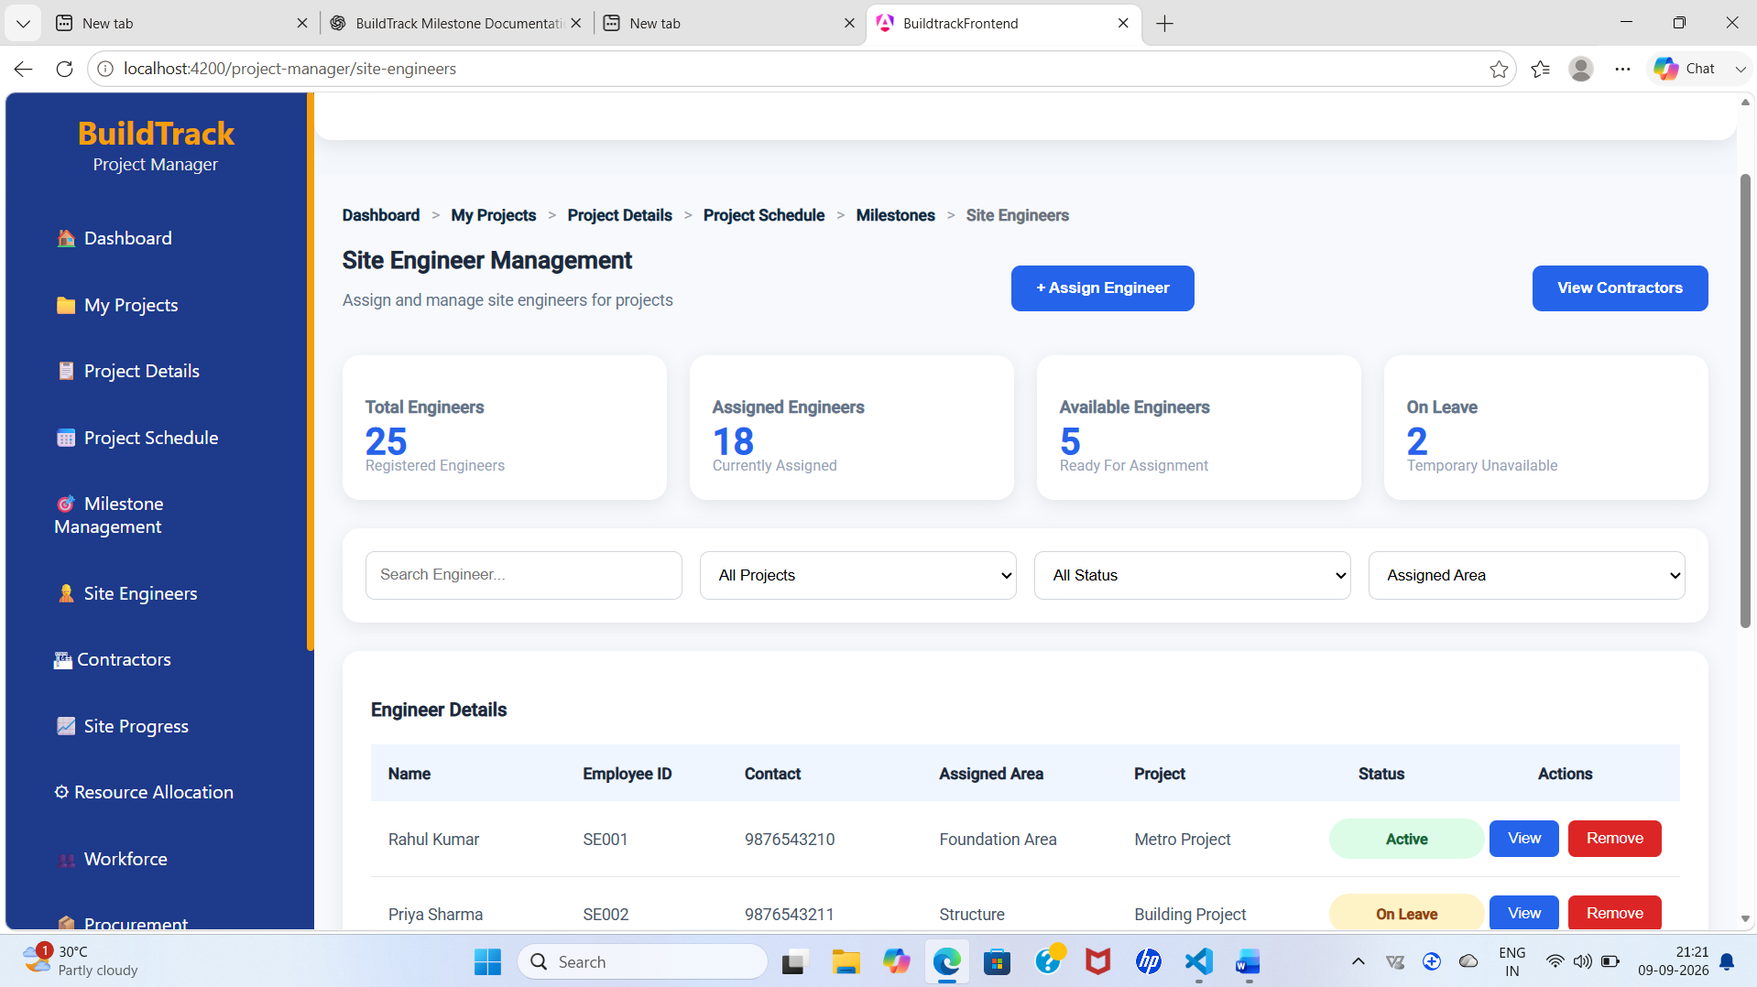

Figure 14: BuildTrack Project Manager – site engineers
Site engineers
6.9 Contractors
The Contractors page allows the Project Manager to view contractors associated with the project.
It provides information about contractor companies and their areas of specialization.
This helps the Project Manager coordinate and monitor contractor involvement in project activities.
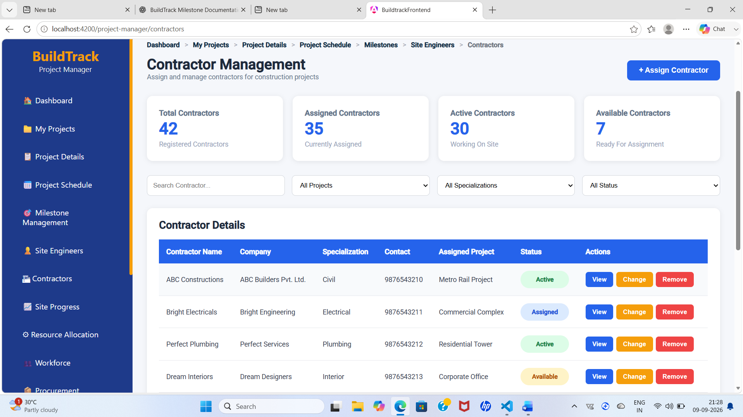

Figure 15: BuildTrack Project Manager – contractors
Contractors

6.10 Site Progress

The Site Progress page allows the Project Manager to monitor the progress of construction activities at the site.
It provides an overview of current progress and work completion status.
This helps the Project Manager track project execution and identify progress-related issues.

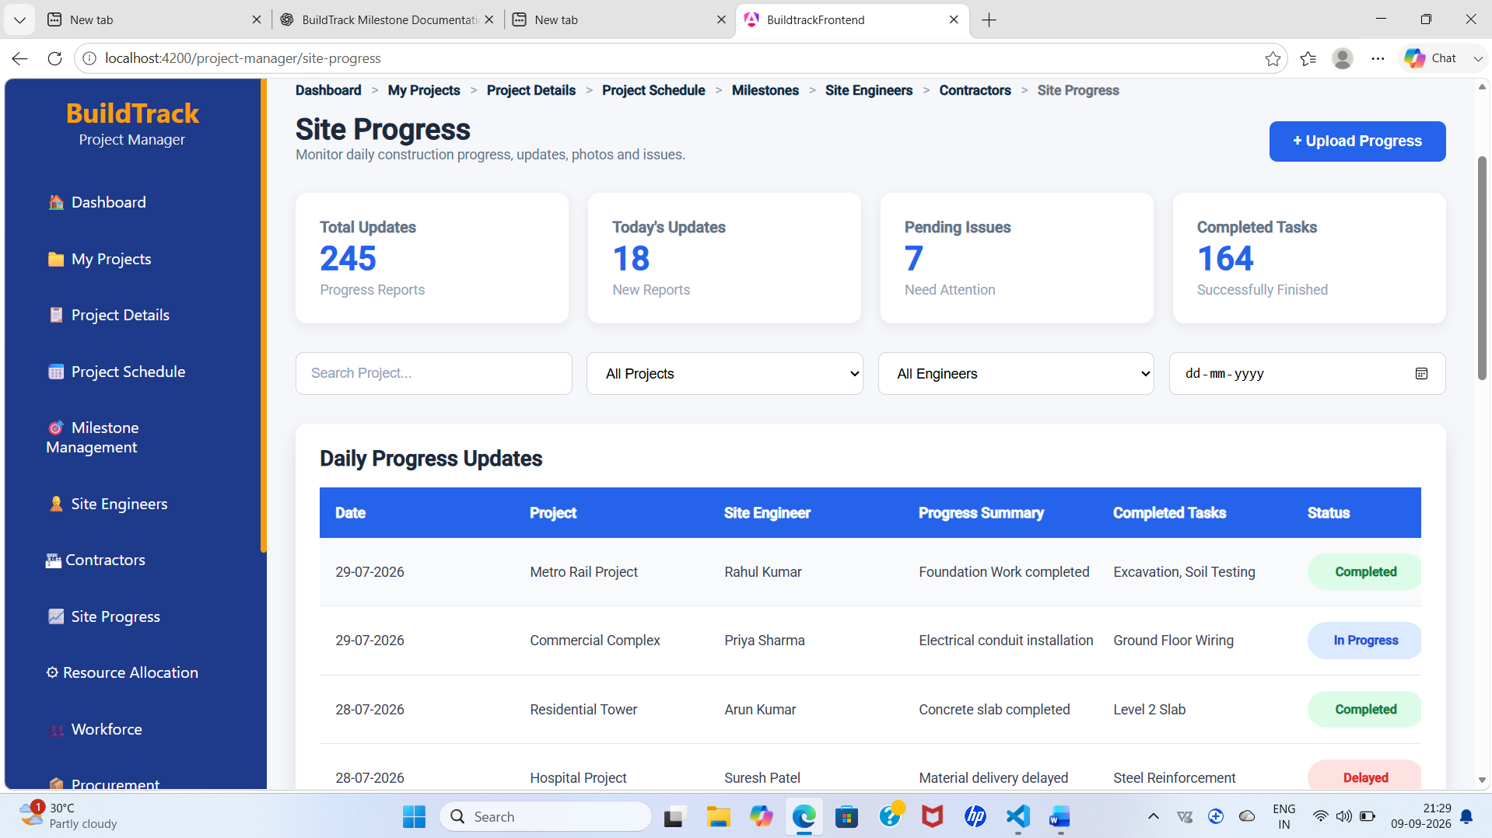

Figure 16: BuildTrack Project Manager – site progress
Site progress

6.11 Resource Allocation
The Resource Allocation page allows the Project Manager to view resources allocated to projects.
It provides information about resource assignments and their association with project activities.
This helps the Project Manager monitor and coordinate resource utilization.

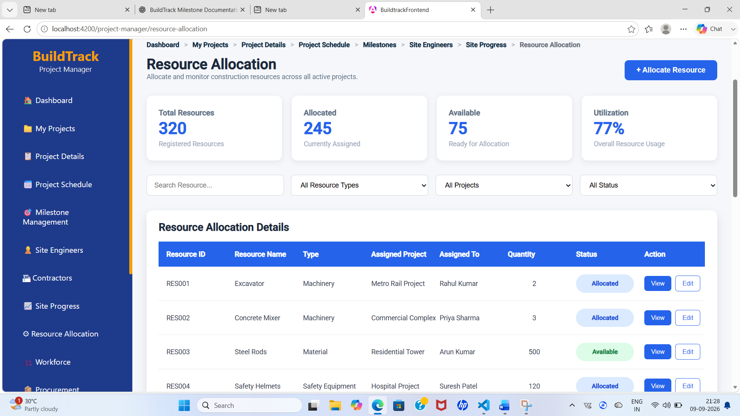

Figure 17: BuildTrack Project Manager – resource allocation
Resource allocation
6.12 Workforce
The Workforce page allows the Project Manager to view workforce and team information associated with projects.
It provides an overview of personnel involved in project activities.
This helps the Project Manager monitor workforce availability and project assignments.
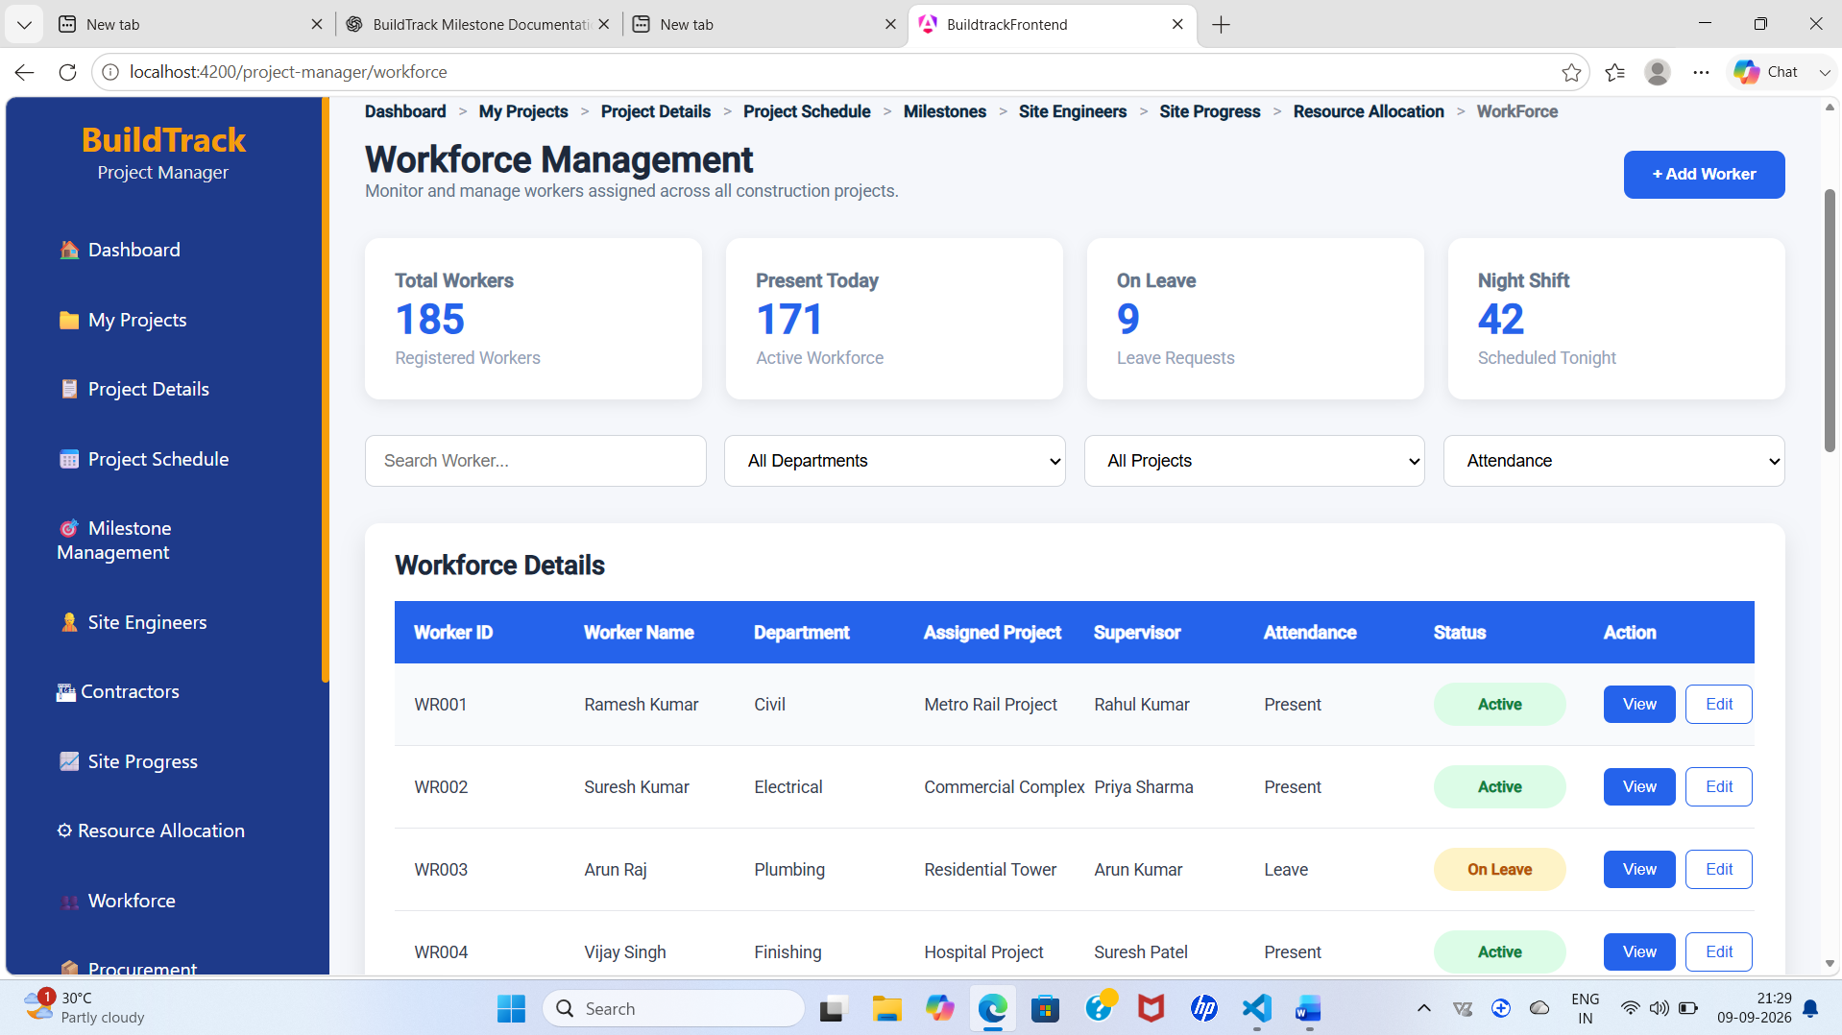

Figure 18: BuildTrack Project Manager – Workforce management
Workforce management

6.13 Procurement Requests
The Procurement Requests page allows the Project Manager to view procurement requests related to project requirements.
It provides information about requested materials, suppliers and procurement status.
This helps the Project Manager monitor material requirements and procurement activities.
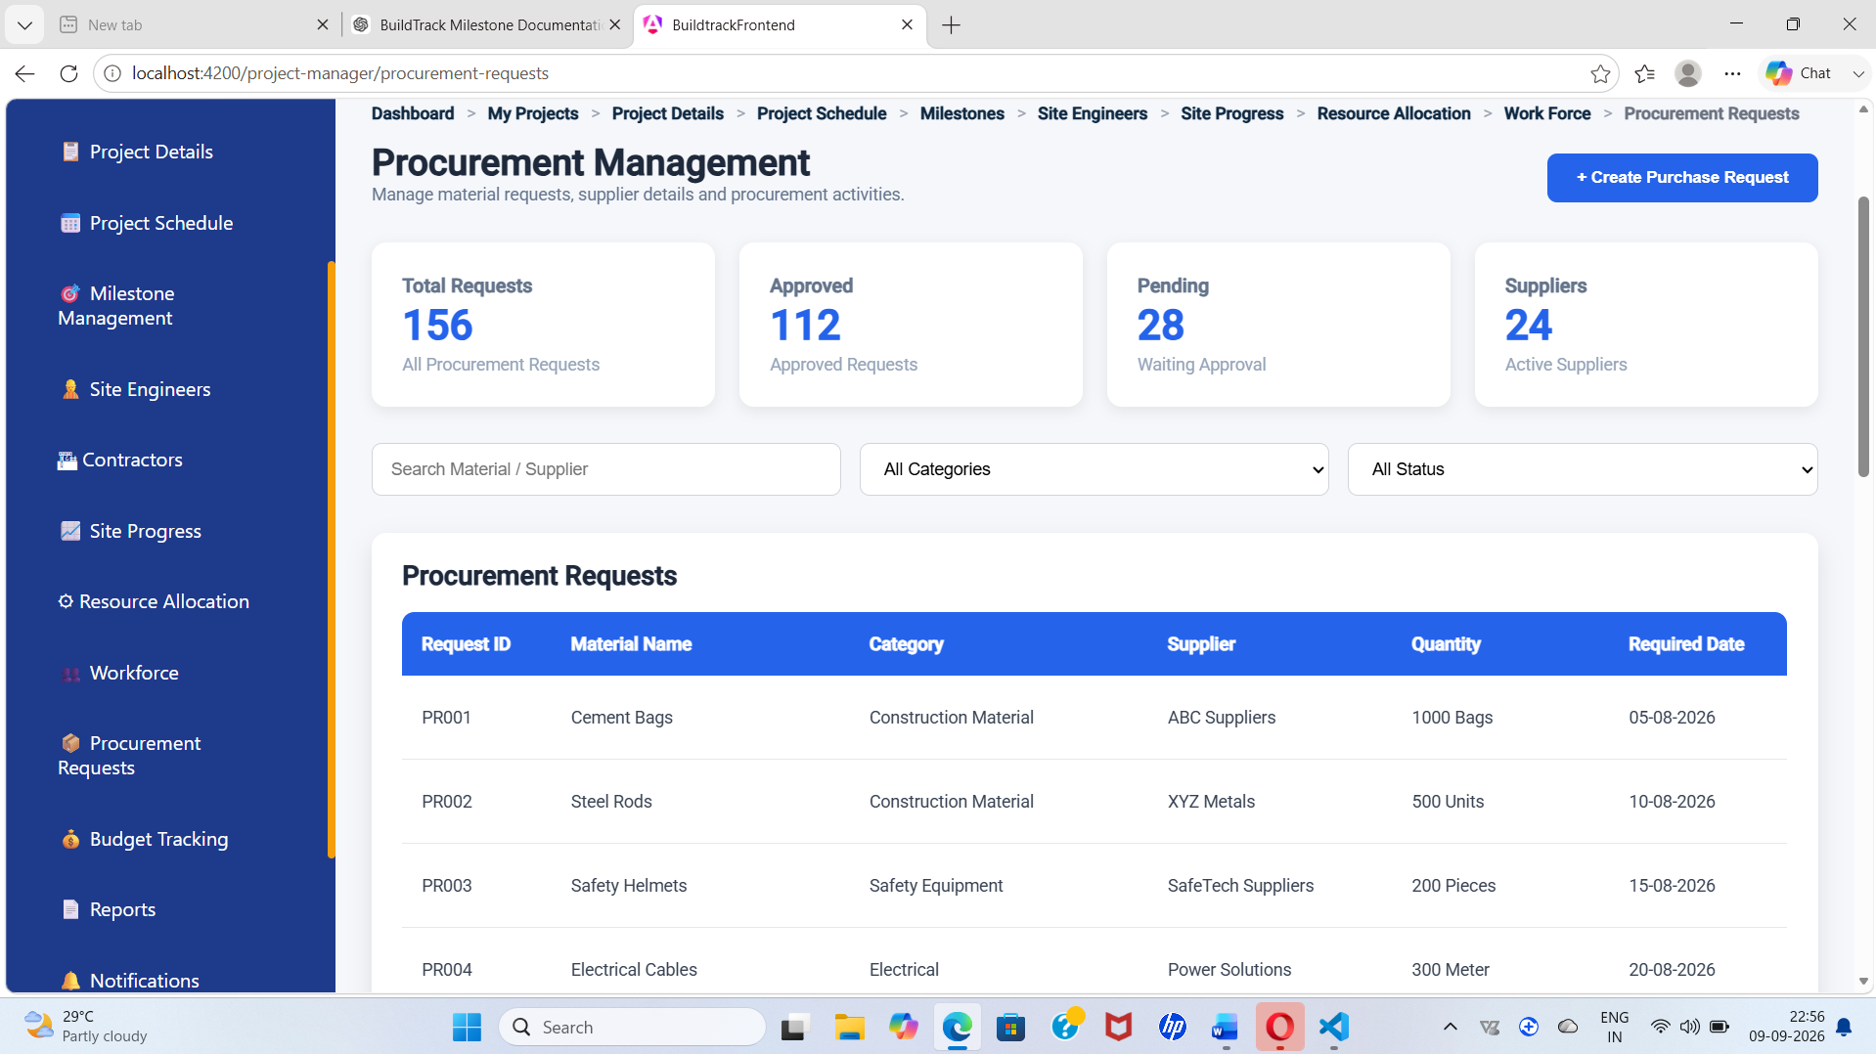

Figure 19: BuildTrack Project Manager – procurement requests
Procurement Requests

6.14 Budget Tracking
The Budget Tracking page allows the Project Manager to monitor the financial status of projects.
It provides information about the project budget, spending and remaining amount.
This helps the Project Manager track budget utilization and control project costs.
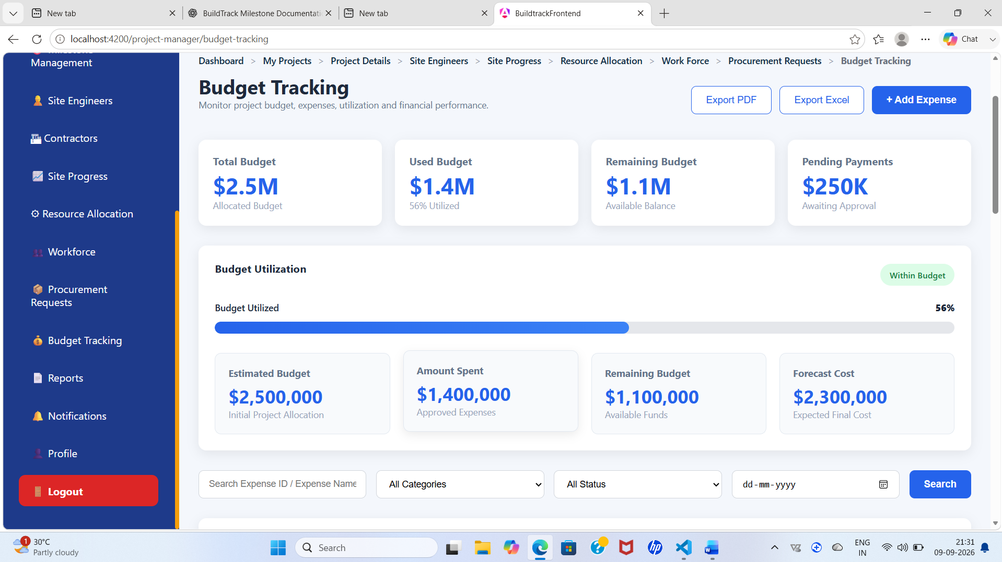

Figure 20: BuildTrack Project Manager – budget tracking
Budget tracking

6.15 Reports
The Reports page provides the Project Manager with access to project-related reporting information.
It helps organize and review important project data and performance details.
This supports project monitoring and informed decision-making.
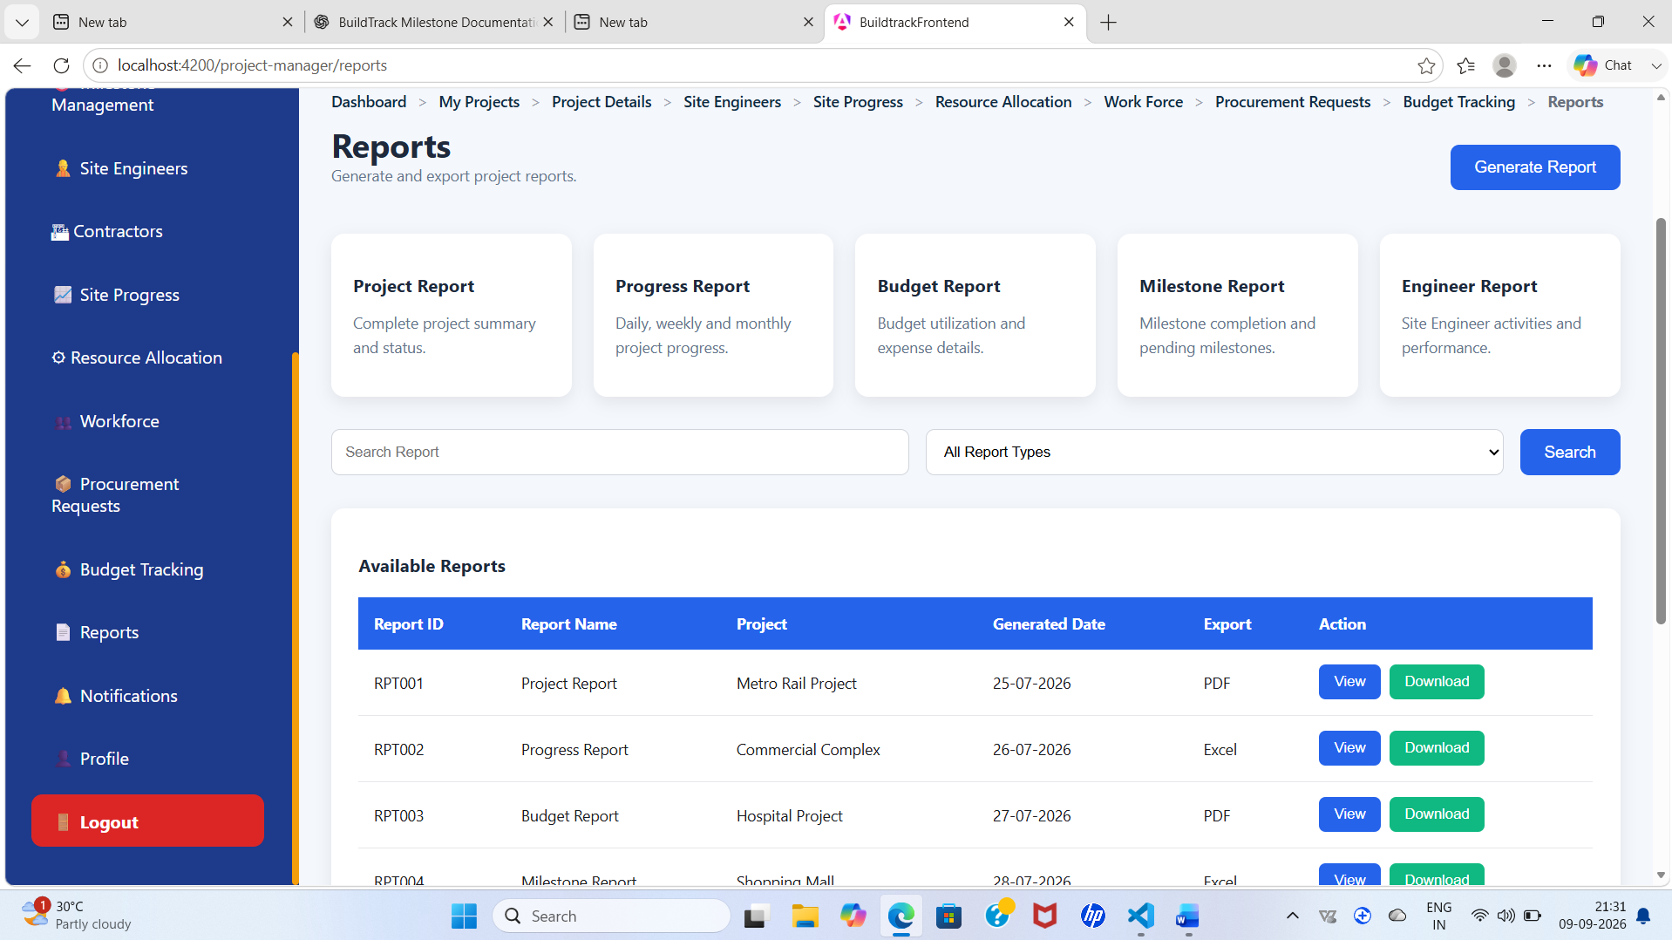

Figure 21: BuildTrack Project Manager – reports
Reports

6.16 Notifications
The Notifications page allows the Project Manager to view project-related notifications and updates.
It provides important alerts and information related to ongoing project activities.
This helps the Project Manager stay informed about changes and important events.
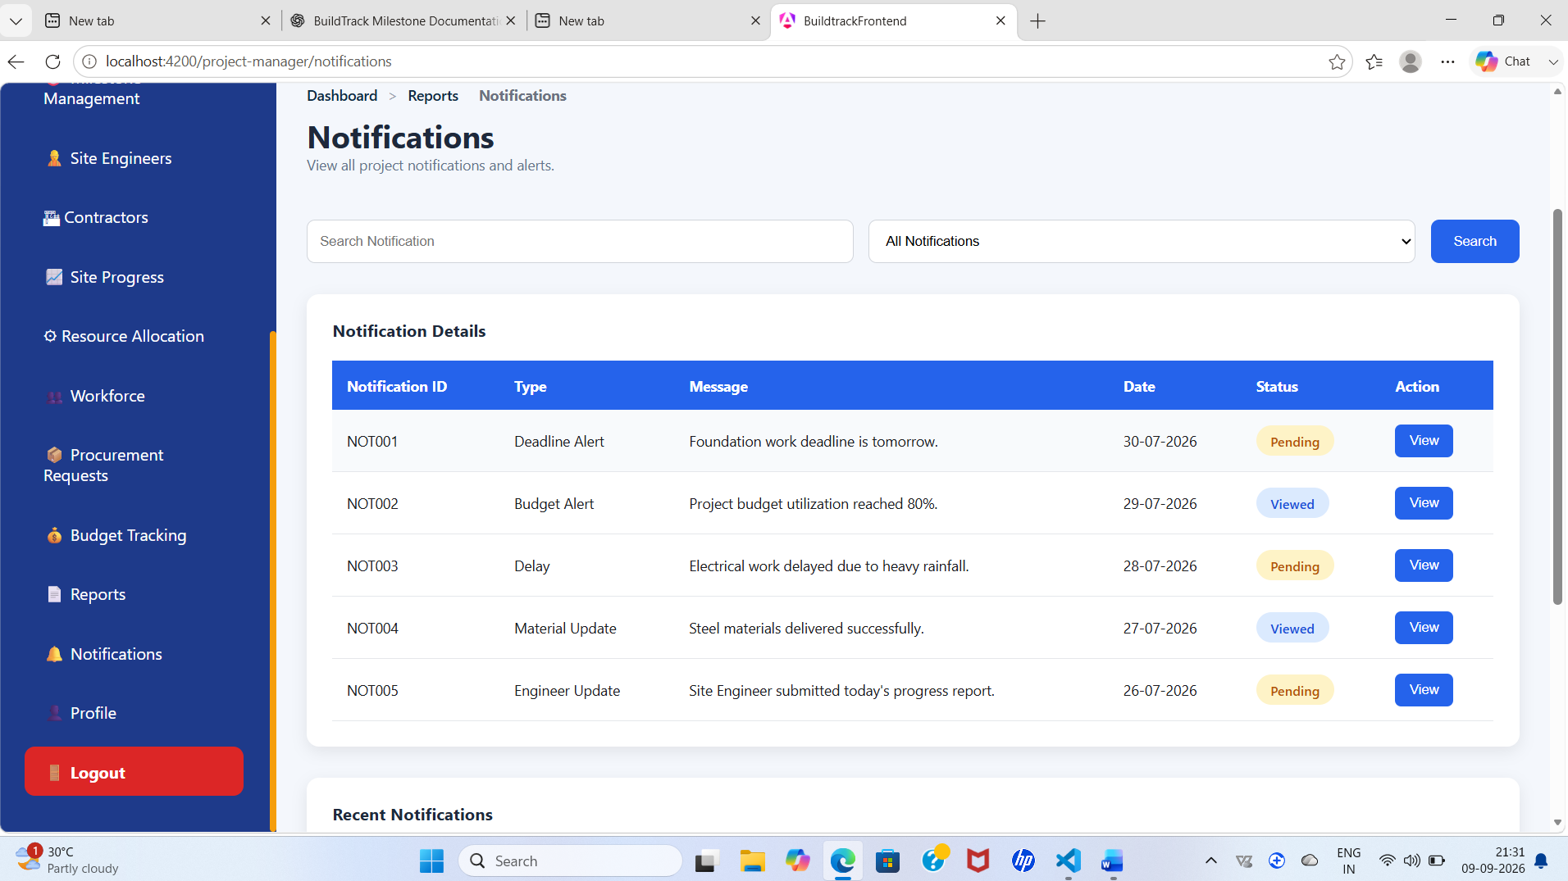

Figure 22: BuildTrack Project Manager – notifications
Notifications

6.17 Profile
The Profile page allows the Project Manager to view their profile information.
It displays the user's relevant account and personal information.
This provides easy access to Project Manager account details.
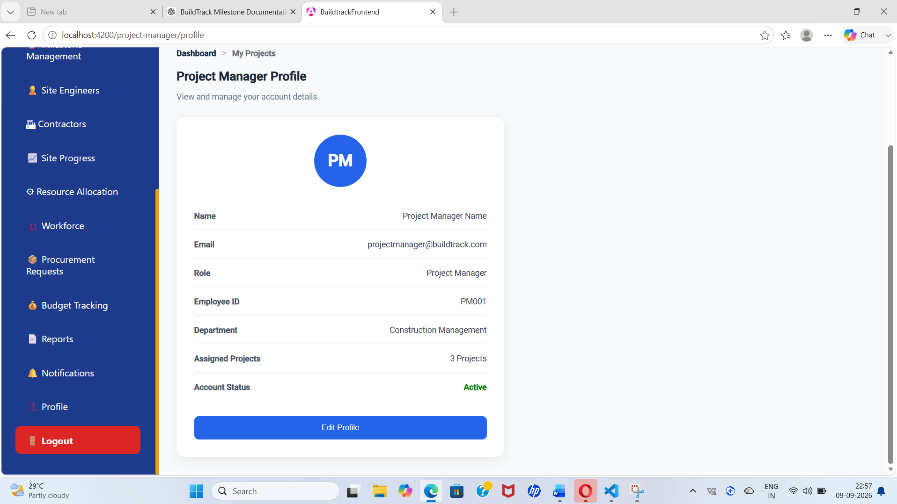

Figure 23: BuildTrack Project Manager – profile
Profile

6.18 Logout
The Logout page allows the Project Manager to securely exit the BuildTrack system.
When logout is selected, the system ends the current user session and navigates to the Login page.
This helps protect user access and ensures the Project Manager can log in again when required.
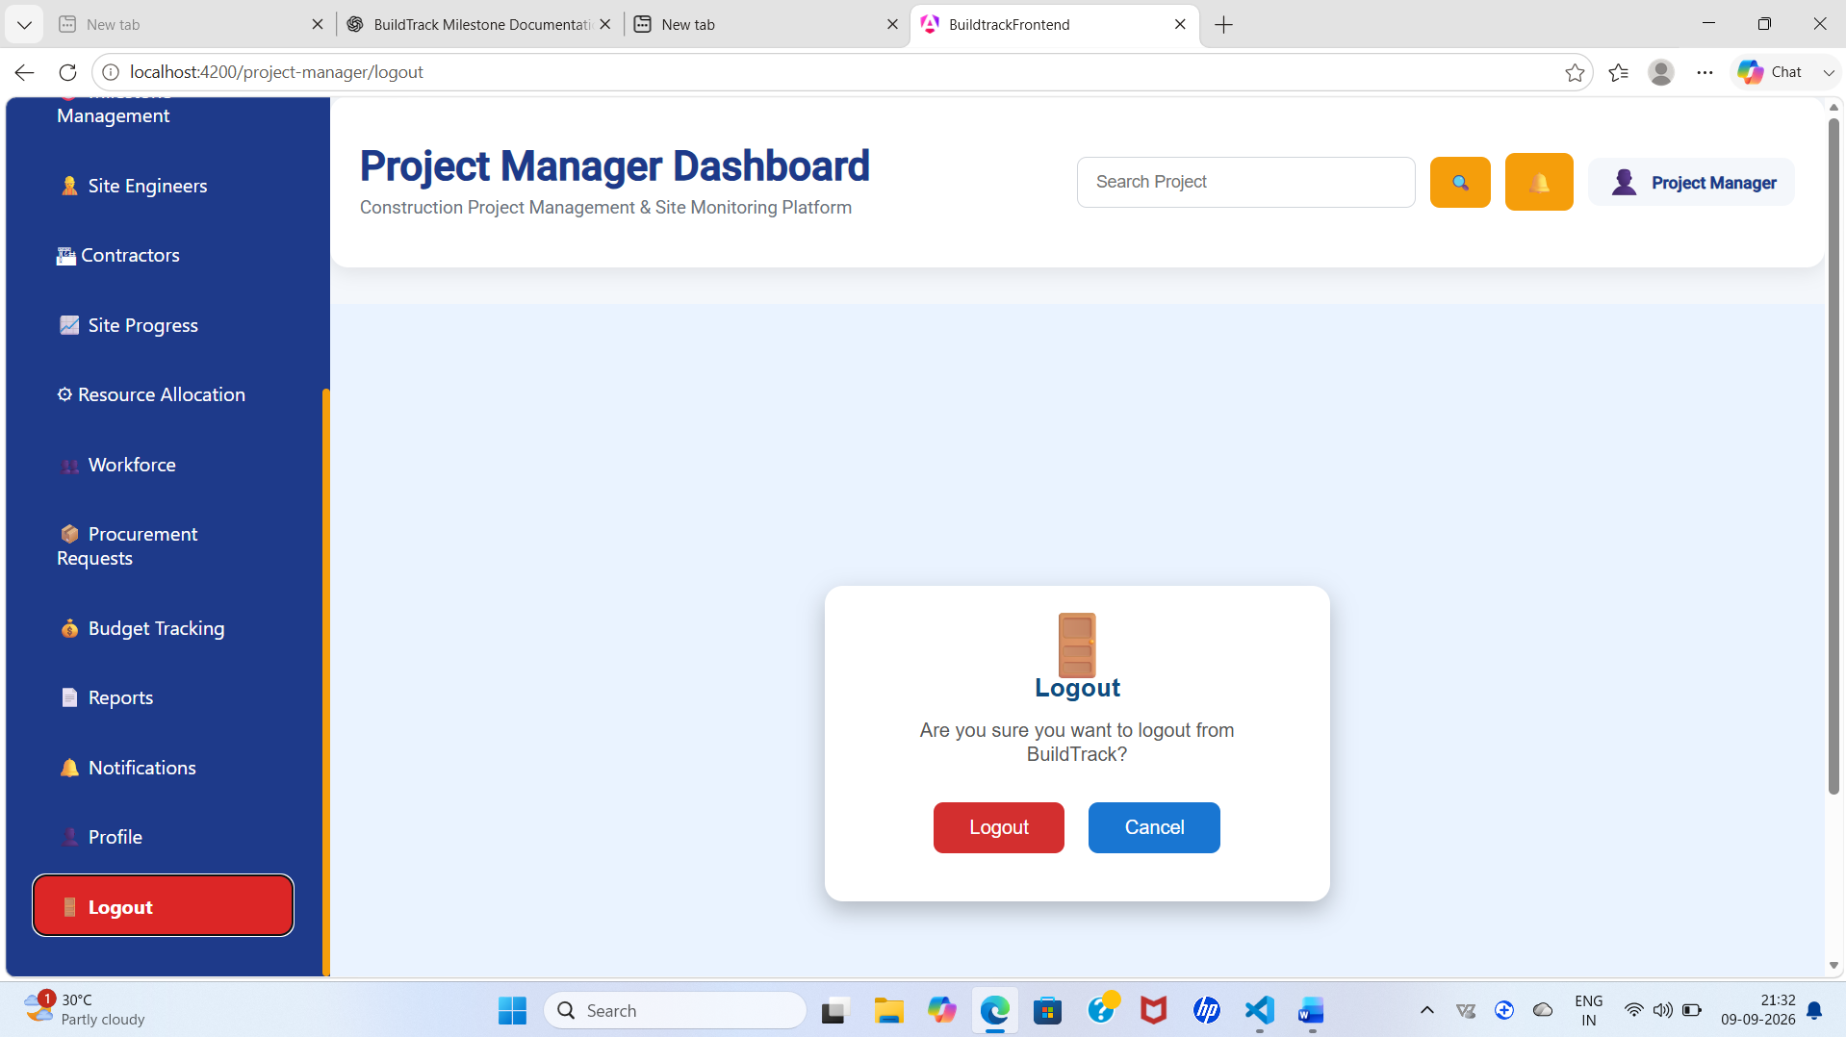
Figure 24: BuildTrack Project Manager – Logout
Logout

6.19 Project Manager Workflow
Step | User Action | System Response | Result
1 | Log in as Project Manager. | Authentication response returns the Project Manager role. | User is redirected to the Project Manager Dashboard.
2 | Review dashboard summary. | Dashboard displays project, milestone, delay and budget indicators. | Manager obtains a high-level project status.
3 | Open My Projects. | Project list and search controls are displayed. | Manager selects a project for review.
4 | Open Project Details. | Project information, progress, milestones, engineers, contractors, resources and materials are displayed. | Manager reviews project execution details.
5 | Open Schedule/Milestones. | Timeline and activity/milestone tables are displayed. | Manager monitors planning and completion status.
6 | Review supporting areas. | Site progress, resource, workforce, procurement and budget views are available. | Manager gets a broader operational picture.
7 | Use reports/notifications/profile. | Corresponding sections are opened through Project Manager navigation. | Manager can review supporting project information.

6.20 Module Outcome
The Project Manager workspace provides a broad frontend representation of construction project monitoring and planning. The dashboard and individual project pages are structured around project progress, milestones, resources, workforce, procurement, budget and reporting concepts.

7. Role-wise Functionality
Role | Milestone 1 Capabilities Evidenced
Administrator | Access administrator dashboard; manage/view user information; add/edit/view user screens; manage/view project information; add/edit/view project screens; administrative analytics/report/audit-log routes.
Project Manager | Access Project Manager dashboard; review assigned projects; inspect project details; monitor schedules and milestones; review site progress, engineers, contractors, resources, workforce, procurement and budget information; access reports, notifications and profile.
Site Engineer | The authentication component contains role-based navigation to the Site Engineer dashboard, and protected Site Engineer routes are defined. Detailed Site Engineer functionality belongs to a later milestone and is not documented as part of Milestone 1.
Other Roles | No additional Milestone 1 functionality is claimed unless evidenced by the current source.

8. End-to-End Milestone 1 Workflow
User → Login → FastAPI Authentication → JWT + Role → Angular Role-Based Navigation → Administrator or Project Manager Workspace → Project/User Information → Monitoring and Planning Views → Operational Output
Input | Processing / Action | System | Output
Email + password | Credential validation and password verification | FastAPI authentication service | JWT access token and role
Role | Role evaluation and route selection | Angular routing | Administrator / Project Manager workspace
User data | Create, inspect or edit user information | Admin user-management screens | Updated/visible user information
Project data | Create, inspect or edit project information | Admin project-management screens | Updated/visible project information
Project status data | Review progress, milestones, schedule and supporting operational sections | Project Manager workspace | Project monitoring and planning view

9. Screenshots and Evidence Checklist
- Figure 1 – Login Page
- Figure 2 – Administrator Dashboard
- Figure 3 – Administrator User Directory
- Figure 4 – Add New User
- Figure 5 – View User
- Figure 6 – Administrator Project Management
- Figure 7 – Project Details
- Figure 8 – Add New Project
- Figure 9 – Project Manager Dashboard
- Figure 10 – My Projects
- Figure 11 – Project Details
- Figure 12 – Project Schedule
- Figure 13 – Milestone Management
Use screenshots from the running BuildTrack application rather than code-editor screenshots. Crop out unrelated desktop areas. Keep the same image width throughout the document and place each screenshot immediately after the relevant feature description.

10. Technical Implementation Summary
Area | Implementation Evidence
Frontend Framework | Angular 22 source structure with standalone components.
UI Components | Angular Material modules are used in the Login component; other pages use HTML/CSS and Angular templates.
Routing | Angular route configuration defines authentication, administrator, Project Manager and other module routes.
Backend Framework | FastAPI application with multiple routers.
Authentication | JWT token creation/verification, role included in login token data, password hashing and verification.
Database Layer | SQLAlchemy engine/session configuration and ORM models for users and project-related entities.
CORS | Backend CORS middleware allows local Angular development origins at localhost:4200 and 127.0.0.1:4200.

11. Limitations / Pending Work
- The Register frontend currently contains a placeholder message rather than a complete registration form.
- The Reset Password frontend currently contains a placeholder message rather than a complete recovery UI.
- The generic Admin User Management page itself is a placeholder; the separate User Directory, Add User, View User and Edit User screens are present.
- Some Project Manager pages display predefined frontend data structures; the documentation should not describe these values as live database values unless backend integration is demonstrated.
- The project source contains later-milestone modules, but they are intentionally not described as completed Milestone 1 deliverables.
- Any backend persistence or API integration that is not demonstrable in the running application should be marked as pending rather than claimed as fully operational.

12. Milestone 1 Completion Summary
Item | Status / Evidence
Authentication login | Implemented in Angular and connected to AuthService/backend login flow.
JWT authentication | Backend token creation and verification are implemented.
Role-based navigation | Login response is used to redirect Administrator, Project Manager and Site Engineer users.
Administrator dashboard | Implemented frontend dashboard with KPI and project-monitoring components.
User management screens | User directory, add, view and edit screens are present.
Project management screens | Project listing, details, add, edit and view screens are present.
Project Manager dashboard | Implemented with project, milestone, site, resource, workforce, procurement, budget, delay, analytics, report, notification and profile sections.
Project planning pages | My Projects, Project Details, Project Schedule and Milestones are present.
Pending frontend work | Registration and Reset Password UIs require completion; some pages use frontend/static data.

13. Conclusion
Milestone 1 establishes the foundation of BuildTrack through authentication, administration and Project Manager workspaces. The source code demonstrates the Angular routing structure, authentication service interaction, JWT-based backend security foundation and a set of administrative and project-management interfaces. The remaining limitations are explicitly identified so that the documentation reflects the actual implementation rather than the planned specification alone.

